Student Degree Record Exchange Standard

Authors Name/s per 1st Affiliation (Author)
line 1 (of Affiliation): dept. name of organization
line 2-name of organization, acronyms acceptable
line 3-City, Country
line 4-e-mail address if desired
Authors Name/s per 2nd Affiliation (Author)
line 1 (of Affiliation): dept. name of organization
line 2-name of organization, acronyms acceptable
line 3-City, Country
line 4-e-mail address if desired

Abstract— Student degree record is currently exchanged manually between educational institutes in Pakistan. The thesis is an effort in suggesting a prototype infrastructure that will enable these institutes to inter-exchange student degree record digitally. Infrastructure represents data format and architecture.
Keywords— data exchange format; bologna process; XML to database mapping

Introduction
It will be added at the end.

Background and Literature Survey
There exists some work which has already been done for exchanging degree records. Let us look into these first.

Bologna Process
It aims to develop European educational framework of standards that will enable different countries to compare and make compatible their educational systems.
http://www.ehea.info/Uploads/Irina/Bologna%20beyond%202010.pdf
There exists many related data exchange standards and related systems;

Data Exchange Standards
These are;

European Qualifications Framework (EQF):
EQF is a common reference framework that will help participating countries to compare national qualifications and make them more readable across Europe. The aim is to promote mobility of workers and learners. This was agreed upon by European universities in 2008 to relate their national qualifications to EQF. The new qualifications from 2012 carry a reference to suitable EQF level.

EQF consists of eight reference levels representing what a learner knows and is able to understand. National qualifications of the participating countries relate to these eight levels ranging from basic level (level 1) to advanced level (level 2). This enables comparison of qualifications in different countries easy, thus providing support for mobility for learners and enabling them to not repeat what they have already learned. The figure below is from [3].

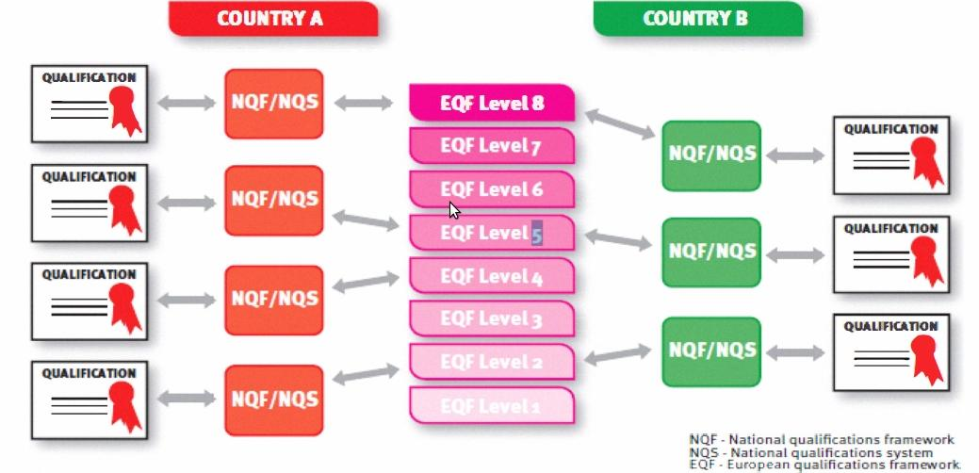

EQF focuses on learning outcomes instead of focusing on learning inputs. It covers all types of education including vocational, professional, school education and qualifications. It tries to validate formal as well as informal education.

Europass:
It is collection of five documents which intend to ease mobility in European job market. These include the Curriculum Vitae, the Language Passport, the Mobility, the Diploma Supplement, and the Certificate Supplement. One can fill himself the Curriculum Vitae, and the Language Passport but the rest of the documents are issued by the corresponding authorities. It follows a template format system. All documents having same format help to achieve neutrality and transparency while presenting one’s skills.

The motto as mentioned on the Europass website’s homepage is as follows;
“Five documents to make your skills and qualifications clearly and easily understood in Europe”

Europass has defined XML schemas for CV and Language Passport. The documents can be exported in XML format when created on Europass. These exported XML documents can be imported to Europass and converted to HTML, PDF, Microsoft Word or ODT templates.

Europass specifies JSON schema according to Internet Engineering Task Force’s JSON specifications draft. The europass JSON vocabulary is close and similar to europass XML schema. The JSON objects for europass documents (CV and Language Passport) can be validated using europass JSON validator.

All these documents have some common XML schema attributes which describe document type, printed preferences.
<DocumentInfo>
<DocumentType>ECV</DocumentType>
<CreationDate>2012-03-01T00:00:00.000+03:00</CreationDate>
<LastUpdateDate>2012-03-01T00:00:00.000Z</LastUpdateDate>
<XSDVersion>V3.0</XSDVersion>
<Generator>XML Editor</Generator>
<Comment>Example CV XML according to XSD v3.0</Comment>
</DocumentInfo>

Europass does not explain details related to degrees or educational certificates in XML certificate.

ECV: Europass Curriculum Vitae is a template which one can create online and it can be exported in xml format. The ECV XML schema contains vocabularies related to document type, printing preferences, personal details, contact details, skills, and educational degrees and institutes. The XML vocabulary related to degree details is very little only to cover the scope of a CV.

ELP: Europass Language Passport is a template. One can create it online and export it in europass xml format. It contains XML vocabulary related to language skills and the scale of six values to score proficiency.

SCHAC: Schema for Academia describes vocabulary related degrees and courses. The schema is written for LDAP (Lightweight Directory Access Protocol). It aims at promoting a common framework to inter-exchange data between educational institutes. It defines attributes that describe individuals and their LDAP profile.[4] For individual attribute specification, use this link. (FVUSPEC, MLO)

Schema for Academia (SCHAC):
Schema for Academia describes vocabulary related degrees and courses. The schema is written for LDAP (Lightweight Directory Access Protocol). It aims at promoting a common framework to inter-exchange data between educational institutes. It defines attributes that describe individuals and their LDAP profile.[4] For individual attribute specification, use this link. (FVUSPEC, MLO).

Dublin Core:
The Dublin core is a simple meta-data standard consisting of set of elements to describe information resources on the network. There are two type of elements; simple and qualifiers. It has 15 simple elements and qualifiers which have additional three elements namely Audience, Provenance and RightsHolder. Qualifiers help in resource discovery.

European Learner Mobility
Some related work has been done recently and systems have been proposed based on the above mentioned standards. These are “The Mobility Project” and “The REST Mobility” projects.

The Mobility Project [1] by Rafal Nagrodzki:
It aimed to provide a platform and infrastructure for exchange of electronic data exchange between educational institutes. Infrastructure includes data format, architecture and the prototype software. The system will called The Mobility later in this thesis.

The Mobility is peer to peer like architecture. Nodes exchange data using SOAP base web service. Other web services like XML-RPC and REST were not used due to their limitations. XML-RPC not have developer defined data-types and character set. REST does not imposes a standard specification, instead it follows set of rules and is used for speedy development of web service interface.

The nodes represented the universities, and their number tend to change. So there was a need for system to maintain this record and UDDI was used. He does not recommended the central or delegated private registry instead gave advantages and disadvantages of both. Central single registry have all information at one place but also it a single point of failure.

The software has two transport modules and each have web interface.

Nagrozki proposed a new standard, defined its vocabulary re-using ideas taken from SCHAC to leverage ISO and RFC rules. Some like grade, credits were taken in inspiration from Eropass Mobility.

Although The Mobility project was started by MUCI and CINECA, two European Higher Education Consortia. Many universities consortia, individual universities and companies joined in later on.

The REST Mobility by Karol Kanski [2]:
This is alternative implementation of Nagrozki’s mobility system. Nagrozki’s system used SOAP web service for data exchange. Karol created a RESTful implementation of the Mobility. The Mobility lacked data model. In The REST Mobility a data model is proposed since REST is resourceful. The model proposed not represents or intends to be a standard.

Information Manyfold [Helvey’s Paper]
Providing a uniform interface for querying data from many sources is the aim of Information Manyfold. It enables a simple user to not worry about locating sources and manually combining results. This leads to concept of Deep Web. Data integration systems give users a common global schema called mediated schema for posting queries. To answer these queries semantic relationships called mappings are needed between mediated schema and the sources schema.
(Local as View (LAV) and Global as View (GAV)).

Critical Analysis
Current Problems:
- Degrees are attested without any data, but by analyzing the certificates and signatures only.
- The verification process is slow. [to be verified]

Proposed Framework
Identify applicable sponsor/s here. If no sponsors, delete this text box (sponsors).
We suggest a data exchange standard and a prototype infrastructure to address these problems. The data exchange standard is called Student Degree Record Exchange Standard (SDRES). It has following key features.
- It is XML based.
- Rafal Nagrodzki’s standard fulfills some vocabulary requirements, we will reuse these terms.
- It will have vocabulary for annual based courses as well as vocabulary related to semester based system.
- It reuses the ideas from SCHAC as it uses ISO norms where possible. For example, using ISO country codes.
Following are some examples of the proposes xml schema;
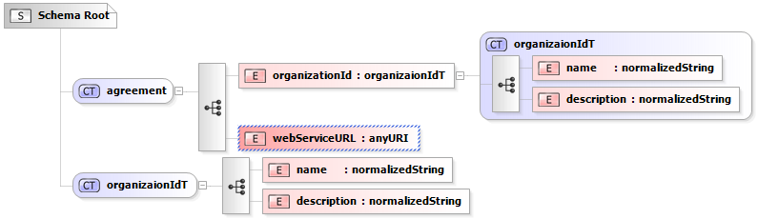
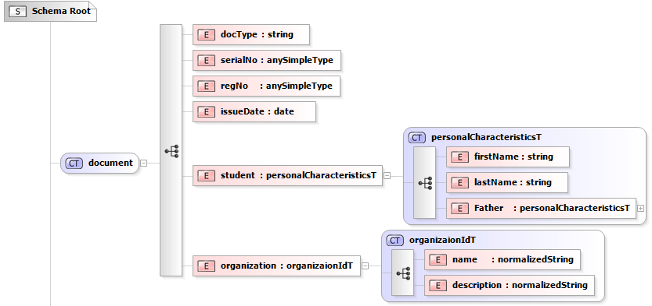
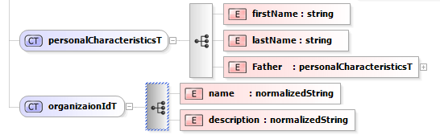

We suggest student exchange system will have distributed architecture. Each university has its own data and signs agreements with HEC for exchanging data with other universities. Each can be a requester plus a provider of data. The circles/nodes in the figure below represent universities
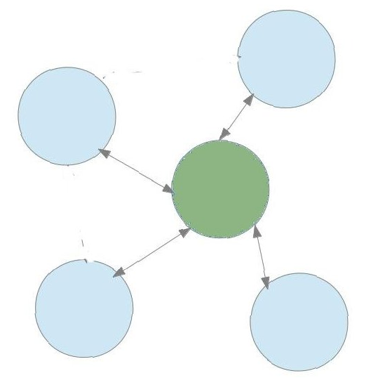

Validation and Evaluation

Business Process
There are many universities. For two universities to exchange data, they have to create an agreement first. The agreement will have the list of documents for which data exchange is available and exchange secrets will be generated.
Making Agreement
To add a university to the system, it needs to make an agreement. The university provides Web-Service details and credentials to the Admin and Admin adds it to the system.

Making Agreement:
For a university to be part of the system, it has to sign an agreement with the HEC. To do this, it has to implement a web service and provide URL to HEC. The HEC will be requester as it requests for the data and the provider is the university.
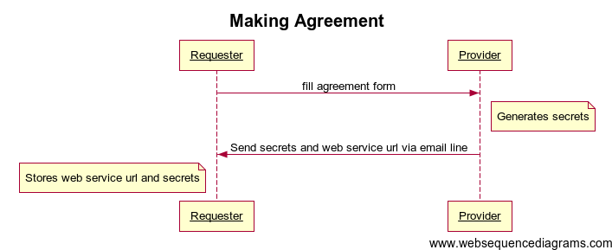
Finding Student Data
To find a student record, the requester selects the university from the list of universities that has made an agreement. After selecting university it provides the search criteria and request will be sent to the corresponding university web-service.

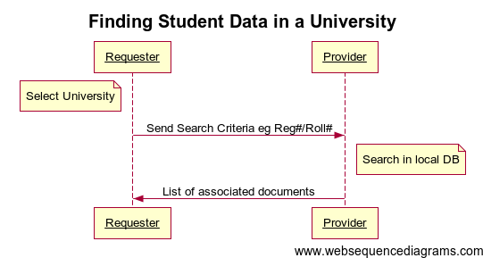

Validating a Document:
To validate a student record, the requester selects the university from the list of universities that has made an agreement. Then it provides the search criteria, document type and request will be sent to the corresponding university web-service.
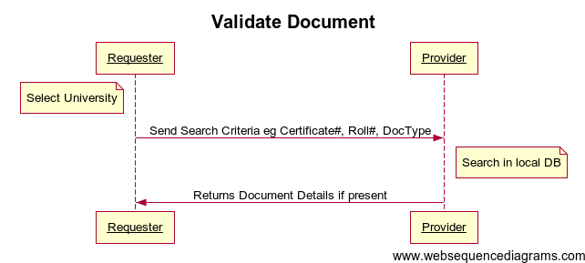

Checking Registration:
To validate a student record, the requester selects the university and it provides the search criteria for example NIC to search for the registration of student in that university.

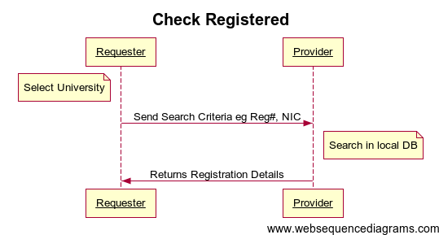

Architecture and Design
From use cases and the business requirements, we suggest student exchange system will have distributed architecture. Each university has its own data and signs agreements with a central authority, in our case HEC, for exchanging data with other universities. Each can be a requester plus a provider of data. The circles/nodes in the figure below represent universities. The arrows represent exchange of data.
This peer to peer like distribute architecture has benefits over adding a middle agent or central server in the system.
- Avoidance from single point of failure.
- Lesser load.
- Each university having control over its own data and thus building trust in the system.

Now we need to decide how these nodes will exchange data. Which protocol will be used for data exchange. There are some choices to be made at this point. We will be using web services for exchanging data as they provide a high abstraction from network issues and use well known standards like XML over HTTP. There are some XML based data exchange protocols on web. These are XML-RPC, SOAP, and REST.

The nodes will exchange data using SOAP based web service in our system. We chose SOAP as it forces to follow a formal standard and supports developer defined data types.

The number of universities can increase when agreements are signed with new universities for exchange data. The web service URLs need to be saved so that requester can retrieve this URL and request that university. This can be achieved by developing a custom system or using UDDI. UDDI is a standard used to discover and save web services URLs.
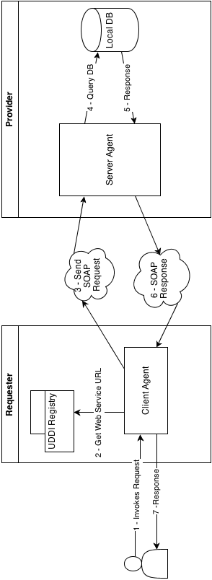

Implementation
First we setup a registry server to store the URLs of the web-services provided by different universities. This is done by making an agreement with each university.

Then take a sample university database having degree record. For sample database we will be using MySQL DBMS. Apply operations on the data-set and return corresponding response. This exchange of information is done in XML SOAP format as it forces to follow a specification. The SOAP server will be implemented in PHP.

Below is the list of operations available;
- Make agreement: Storing web-service URL in the registry.
- Find student data in university using SOAP service.
- Validate a degree document.
- Check registration of a student in a university.

When using SOAP format, it is optional to use WSDL. It is a web service description language document. We generated this document using php2wsdl tool. This is an open-source PHP library used for generating WSDL document.

Conclusion
This is to be added at the end.

References
These are to be updated.
- G. Eason, B. Noble, and I.N. Sneddon, “On certain integrals of Lipschitz-Hankel type involving products of Bessel functions,” Phil. Trans. Roy. Soc. London, vol. A247, pp. 529-551, April 1955. (references)
- J. Clerk Maxwell, A Treatise on Electricity and Magnetism, 3rd ed., vol. 2. Oxford: Clarendon, 1892, pp.68-73.
- I.S. Jacobs and C.P. Bean, “Fine particles, thin films and exchange anisotropy,” in Magnetism, vol. III, G.T. Rado and H. Suhl, Eds. New York: Academic, 1963, pp. 271-350.
- K. Elissa, “Title of paper if known,” unpublished.
- R. Nicole, “Title of paper with only first word capitalized,” J. Name Stand. Abbrev., in press.
- Y. Yorozu, M. Hirano, K. Oka, and Y. Tagawa, “Electron spectroscopy studies on magneto-optical media and plastic substrate interface,” IEEE Transl. J. Magn. Japan, vol. 2, pp. 740-741, August 1987 [Digests 9th Annual Conf. Magnetics Japan, p. 301, 1982].
- M. Young, The Technical Writer’s Handbook. Mill Valley, CA: University Science, 1989.

